Predictive Modeling for Post-Operative Visual Outcome in Craniopharyngioma

Goal
The goal of this research is to develop a predictive model that uses pre-operative information, including MRI scans, clinical history, and visual function measurements, to estimate the risk of postoperative visual deterioration.

Context
Craniopharyngiomas (CPs) are rare, aggressive epithelial tumors often located near the optic pathways. This location frequently leads to severe visual impairment, which is present in 37% to 68% of patients at diagnosis.¹
The primary clinical challenge is the high variability of surgical outcomes. While surgical decompression can improve vision in some patients, others experience significant and often irreversible visual deterioration postoperatively. Given the reported incidence of post-operative visual deterioration (9.1% in certain cohorts)², the ability to reliably predict visual outcomes pre-operatively represents an urgent and clinically significant unmet need in neurosurgery.

Research Strategy and Predictive Pipeline
The overall research strategy integrates quantitative imaging features with patient-specific clinical data using a multi-step machine learning pipeline (Figure 1).
- Imaging Feature Generation
This phase uses deep learning and radiomics to quantify the tumor's anatomical relationship with the optic chiasm.
- Tumor Segmentation: A state-of-the-art deep learning model, nnUNet, is trained to automatically segment the craniopharyngioma tumor from the patient’s MRI scans, generating a 3D tumor mask.
- Radiomics Feature Extraction: Radiomic features are extracted by comparing the 3D tumor mask with a standardized anatomical reference (Chiasm Prior). These handcrafted features quantify the tumor's spatial relationship to the chiasm, including Distance, Overlap, and Contact.
- Rad-Score Generation: Handcrafted radiomic features and latent representations from the nnUNet model are passed to a feature selection model, such as LASSO. The selected, most predictive features are combined into a quantitative metric, the "Rad-Score," which serves as a proxy for the tumor's imaging-based invasiveness.
- Final Predictive Model
The final step integrates the quantitative imaging score with clinical data to generate the definitive risk prediction.
- The imaging-based Rad-Score is combined with pre-operative clinical variables (e.g., MFI5, MFI11, CCI, EOR, Age, Sex) and vision test measurements (e.g., VIS Field Deficit, VIS Score).
- This comprehensive dataset is used to train a final machine learning CLASSIFIER.
- The model will predict the patient's Visual Outcome: Unchanged, Improved, or Worsened. A final model will be selected from a set of candidates (e.g., Logistic Regression, Random Forrest) based on classification metrics (accuracy, sensitivity, specificity).
Risk Score = Classifier(Rad-Score, Clinical Variables, Vision Tests)
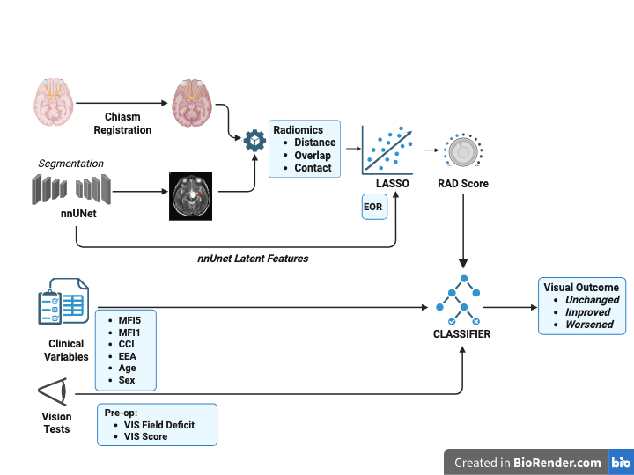
Figure 1: Modeling Pipeline
References
[1] Craniopharyngiomas | Research Starters - EBSCO, https://www.ebsco.com/research-starters/health-and-medicine/craniopharyngiomas
[2] Qiao, N., Li, C., Zheng, F., Zhang, L., Yang, X., Xu, J., Chen, X., Qiao, H., Zhang, Y., & Gui, S. (2025). Development and validation of a radiomics-visual evoked potential nomogram for preoperative prediction of visual outcome after endoscopic craniopharyngioma resection. Journal of neurosurgery, 142(6), 1663–1673. https://doi.org/10.3171/2024.9.JNS241482
[3] Postoperative visual recovery following surgical treatment of craniopharyngiomas https://www.researchgate.net/publication/301332234_Postoperative_visual_recovery_following_surgical_treatment_of_craniopharyngiomas
[4] Chen, C., Zhang, T., Teng, Y., Yu, Y., Shu, X., Zhang, L., Zhao, F., & Xu, J. (2023). Automated segmentation of craniopharyngioma on MR images using U-Net-based deep convolutional neural network. European radiology, 33(4), 2665–2675. https://doi.org/10.1007/s00330-022-09216-1
[5] Calandrelli, R., D’Apolito, G., Martucci, M., Giordano, C., Schiarelli, C., Marziali, G., Varcasia, G., Ausili Cefaro, L., Chiloiro, S., De Sanctis, S. A., Serioli, S., Doglietto, F., & Gaudino, S. (2024). Topography and Radiological Variables as Ancillary Parameters for Evaluating Tissue Adherence, Hypothalamic–Pituitary Dysfunction, and Recurrence in Craniopharyngioma: An Integrated Multidisciplinary Overview. Cancers, 16(14), 2532. https://doi.org/10.3390/cancers16142532
[6] Kwang Sheng, N., & Wan Hitam, W. H. (2022). Acute Blindness in the Elderly With Craniopharyngioma. Cureus, 14(7), e26880. https://doi.org/10.7759/cureus.26880
[7] Repka, M. X., Miller, N. R., & Miller, M. (1989). Visual outcome after surgical removal of craniopharyngiomas. Ophthalmology, 96(2), 195–199. https://doi.org/10.1016/s0161-6420(89)32914-9
[8] Stanford, Doctor fernandez-Miranda, MD About Craniopharyngiomas
[9] Goldenberg-Cohen, N., Ehrenberg, M., Toledano, H., Kornreich, L., Snir, M., Yassur, I., Cohen, I. J., & Michowiz, S. (2011). Preoperative Visual Loss is the Main Cause of Irreversible Poor Vision in Children with a Brain Tumor. Frontiers in neurology, 2, 62. https://doi.org/10.3389/fneur.2011.00062
[10] Ronneberger, O., Fischer, P., & Brox, T. (2015, October). U-net: Convolutional networks for biomedical image segmentation. In International Conference on Medical image computing and computer-assisted intervention (pp. 234-241). Cham: Springer international publishing.
[11] Isensee, F., Jaeger, P. F., Kohl, S. A., Petersen, J., & Maier-Hein, K. H. (2021). nnU-Net: a self-configuring method for deep learning-based biomedical image segmentation. Nature methods, 18(2), 203-211.
[12] N. McConnell, N. Ndipenoch, Y. Cao, A. Miron, Y. Li- Exploring advanced architectural variations of nnUNet - Neurocomputing, 560 (2023), Article 126837

